Fabulous festive offers at The Sukhothai Shanghai

Purchase on the hotel’s official WeChat shop (TheSukhothaiShanghai) before 15 December to enjoy early bird specials.

Year-end gathering in different scales
Plan a big party to mark the end of a fruitful year at The Sukhothai Shanghai’s versatile event space caters up to 200 guests. Prices start from RMB7,888 per table of ten including three hours free flow of selected beverages.
Intimate groups can go to URBAN Café for sharing plated menu and get complimentary drinks. Prices start from RMB218 for three dishes. Or chill out in The ZUK Bar with free-flow deal starting from RMB188 per person.

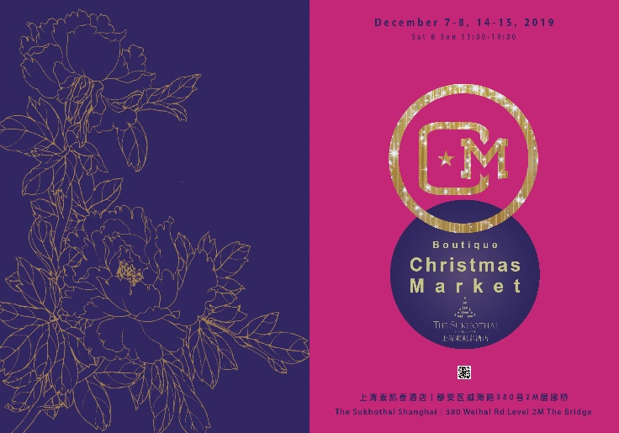
Weekend Christmas Market at The Bridge (Level 2M at Beans & Grapes)
7 to 8 December and 14 to 15 December, 11am to 7pm
The Sukhothai Shanghai hosts a boutique Christmas market with a wide array of handcrafted souvenirs from jewelries, accessories to artisan foods for a perfect holiday gifts. For kids who are keen to try their hands on the baking are welcome to join our Christmas cooking-making workshop. To spread more joy, guests who attended the event, will stand a chance to win food and beverage voucher.

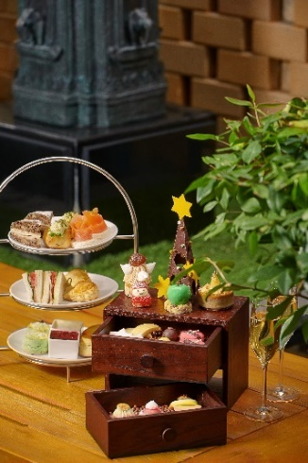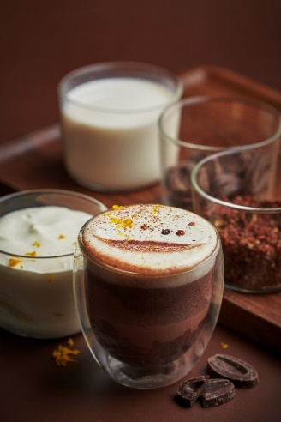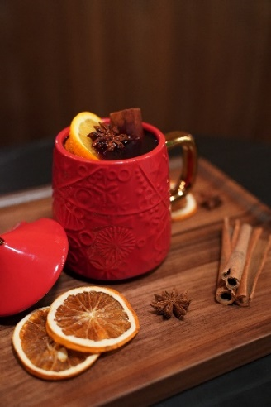
Festive Afternoon Tea and Winter Drinks at URBAN Café & Lounge
30 November to 31 December, 2.30pm to 5pm
The afternoon tea favourites are dressed up for Christmas including turkey ham and cheese brown bread sandwiches, rose lychee Santa cap, Christmas cookies, Chocolate truffle, and more. Spiced hot chocolate and mulled wine are served to make the cold winter comforting. Festive afternoon set for two at RMB416; winter drinks start from RMB48

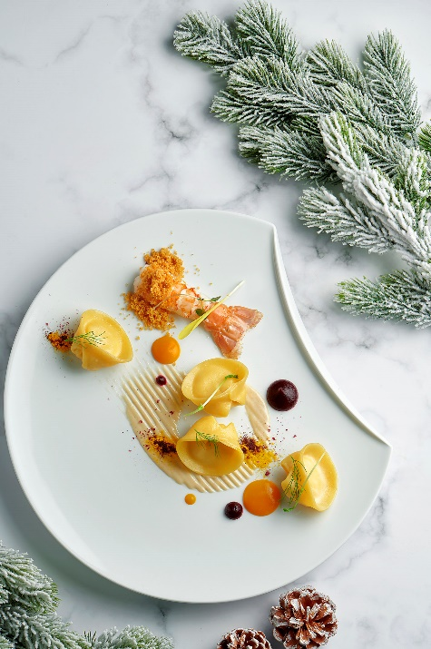

An Intimate Italian Christmas Eve dinner and New Year’s Brunch at La Scala
24 December, 6.00pm to 10.00pm; 1 January, 11.30am to 2.30pm
Revel in the sophisticated five course menu with Italian festive delicacies including herb crusted cod fillet, turkey breast roulade and grilled M3 Angus beef rib eye steak. RMB538 per person
On 1 January, relish La Scala’s award-winning brunch with the scrumptious spread of chef’s table to start, select any two dishes from the menu, then head to the dessert section for some holiday treats. Price at RMB328 per person

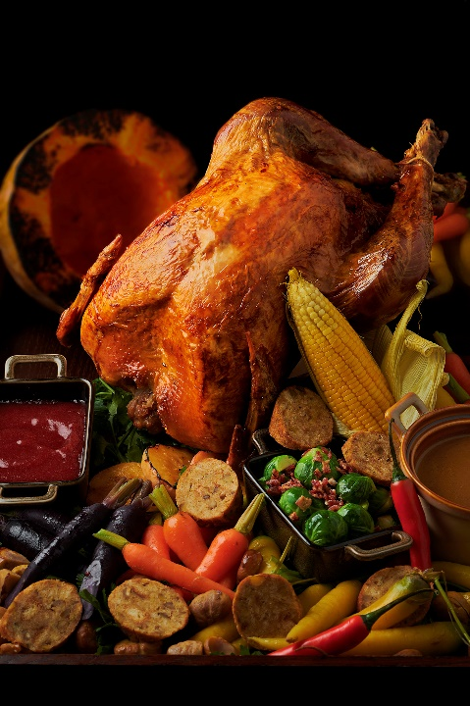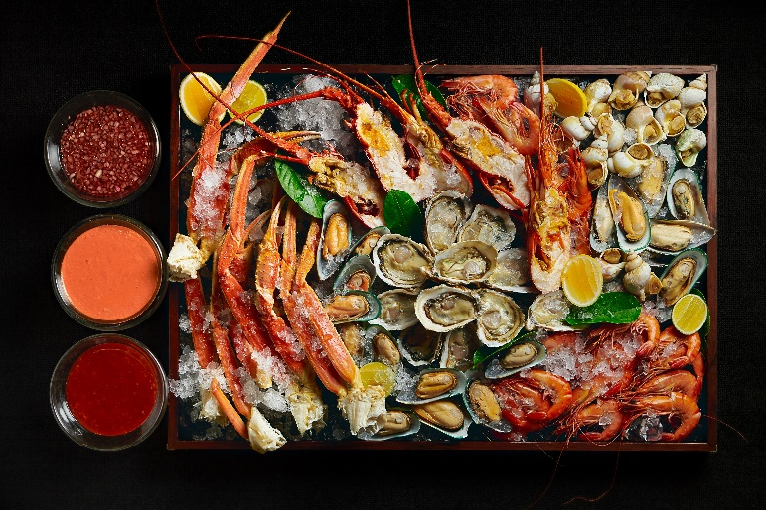

A Jolly Christmas Eve to Remember at URBAN Café
24 December, 5.00pm to 7.30pm; 7.30pm to 10.00pm
Christmas Eve is a decadent affair at the URBAN Café. The tantalising lip-smacking spread with a seafood and salad stations and succulent roasts including the roasted bronze turkey with all the trimmings, roast beef, honey-glazed ham. The meal is further sweeten by the traditional treats of log cakes and pudding. Look out for Santa who will pop-in with a gift for each child and other entertainment to keep both adults and kids amused. Price start from RMB348 per person; free for kids up to 6 years old and 50% off for kids between 7 to 12 years old

Countdown Party at The ZUK Bar
31 December 2019 from 10pm onwards
End 2019 with a big celebration at The ZUK Bar’s countdown party. A fun-filled night with unlimited selected beverage and cocktail by guest bartender and light bites. A raffle of thrilling prizes including a 90-minute Himalayan pink salt body treatment, one-year supply of free coffee at Beans & Grapes, and staycation at The Sukhothai Shanghai awaits you. Price start from RMB188 per person

‘Think Winter’ staycation
now until 29 February 2020
Fancy a getaway in the cold winter? The Sukhothai Shanghai launches ‘Think Winter’ package with one night accommodation in an Executive Room plus RMB300 dining credits to be consumed at its iconic restaurants and bars. Rate starts from RMB1,580 per night

* Price is subject to 10% service charge and prevailing value-added tax at 6.6%
For reservation, contact us at
Tel: (021) 5237 8888
Add: 380 Weihai Road, Jingan District, 200041 Shanghai
Email: wine&dineshanghai@sukhothai.com

